Moving a motion & Fancy meeting words

Ever wandered what these words mean? It is a whole new language and can be very confusing if you’re not used to the meeting lingo when it comes to making decisions as a committee.
Check out the chart below to see how to use them! Still not sure? Come and chat with your CDO!
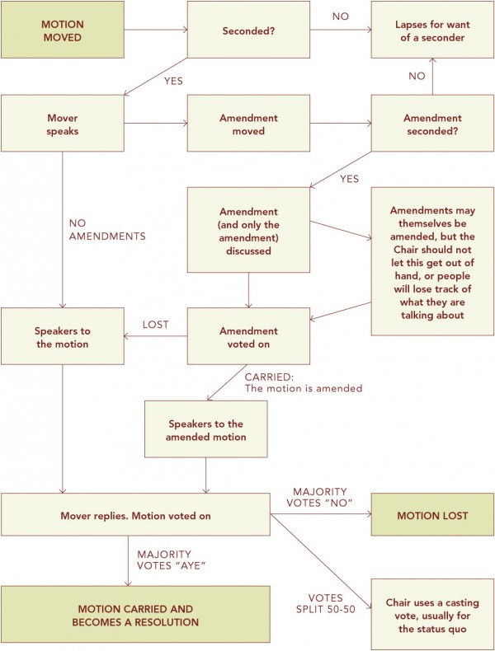

Agenda: A schedule of items drawn up for discussion at a meeting
AGM: Annual General Meeting – an annual meeting that all members can attend
Apologies: Excuses given in advance for inability to attend meeting
Casting Vote: a chairman may use a casting vote to reach a decision
Chairman: Leader (president) given authority to conduct a meeting
Committee: a group of people usually elected to conduct agreed business
Consensus: agreement by general consent of everyone at the meeting
Constitution: a set of rules governing activities of the club
Convene: to call a meeting
Motion: the name given to a proposal when it is being discussed at a meeting
Mover: one who speaks on behalf of a motion Eg. ‘Robbie moves that the club shall apply for an OUSA grant, and James is to apply on behalf of the club’
Quorum: the number of people needed to be in attendance for a meeting to be legitimate and so commence
Seconder: one who supports the proposer of a motion or proposal by ‘seconding it’ eg. Kate seconds Robbie’s motion above.
Secretary: committee official responsible for the internal and external administration of a committee (taking the minutes)
Treasurer: committee official responsible for its financial records and transactions
Unanimous: all being in favour of the decision

